# FAQ

## What is BetOnNXT?

BetOnNXT is an online gambling game which uses digital coins to bet on.

## How to play?

The idea of the game is to bet on the future NXT coin average exchange rate change. Every player gets the current NXT 7d% change rate by visiting <https://coinmarketcap.com/currencies/views/all/> .

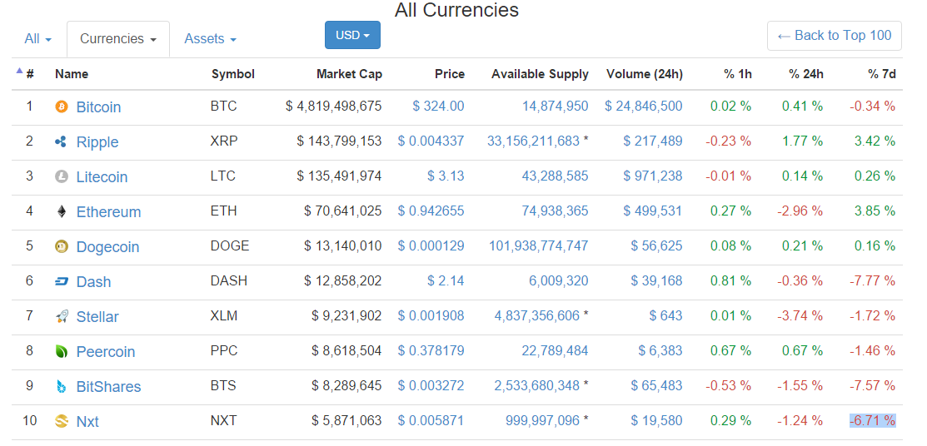

This rate is being regularly updated every 5 minutes.

## How to bet?

In order to place a bet, user must send 100NXT (of other amount of NXT coins what will be set) to the game wallet account number. With 100NXT coins, user must fill in an unencrypted message field with predicted 7d% change value. Message can only contains numbers with 2 digits precision (for decimal separation a dot ‘.’ or a comma ‘,’ can be used). If an invalid message will be send (eg. Text or the message will be encrypted) then the deposited funds will be refunded decreased by a NXT transfer fee.

*The more flexible way of placing bets is to register at BetOnNXT.com . While registering, the user’s NXT account must be provided. This gives the ability of placing bets directly from the game, checking the balance and depositing new funds. Also the history of the last placed bets will be available.*

*If user does not have his own NXT account, it can be created by opening an online wallet at* [*www.mynxt.info*](http://www.mynxt.info) *or by downloading the NXT client which can be found here:* [*www.nxt.org*](http://www.nxt.org)*.*

*Important note: While placing a bet from the game website, user must provide his secret passphase. We do not store this password anywhere, but its strongly recommended to create a dedicated wallet for this game and do not hold any significant amount of NXT there, which you are not ready to lose. The game is protected by the SSL encryption to encrypt the information what is being send.*

### Time slots

Each bet is allocated to the current time slot. Time slot is a being opened from the beginning of the current hour and its being closed at the end of current hour. (eg. From 10:00 AM to 11:00 AM). When the time slot is closed, the game selects winners after one hour.

Eg. Mike has placed a bet on 12.5% 7d% change value by sending 100NXT with a non-encrypted message. The bet was placed at 2015-11-23 1:24 PM so it goes to the time slot named “2015-11-23 1:00 PM”. At 2:00 PM time slot is closed and no other bets can be placed there. At 3:00 PM game selects winners from all bets placed for given time slot.

### Selecting winners

While selecting winners, game gets the current NXT 7d% change rate from <https://coinmarketcap.com/currencies/views/all/> . If this step fail for any reason (eg. Coinmarketcamp web page will be down) all placed bets will be refunded. Each refund costs NXT transaction fee. (eg. Mike has placed a bet of 100NXT but the game will refund him 99NXT in case of an error and transaction fee equal 1NXT).

### How the winners are selected

As it is hard to place a precise bet, the game uses a win margin which is highlighted on the game main page. This margin can be adjusted if the game will be too easy or difficult. If the placed bet was close to the winning rate, win margin selects winners who bet the closes to the winning vote.

(eg. Mike placed a bet with a vote for 12.5% but the winning vote is 12.8%. The game win margin is set to 0.3, so Mike bet still wins)

### Winning, prizes, game profit

## Game profit is set at 10% of the won. From that won the prize for the next game is subtracted. The game parameters like prize, bet size, win margin can be adjusted (by me) to get the best betting experience.

## Winning rules: *examples – this algoritm should be described.*

1. We have 100 bets each worth of 100 NXT.

Game has selected 2 winners

The prize from previous games is 10 000 NXT

The prize is set at 1000 NXT

Game profit takes 10% of 100 * 100NXT + 1000 NXT, so 10% * 11 000 is 1100NXT

Each winner gets (total Amount – game Profit) / 2 = 4950

Sending FEE is set to 1 NXT, so in the end the user will get 4949 NXT

The game profit is 1100NXT but the prize is set at 1000NXT, so the 1000NXT is subtracted and passed as a prize for the next game.

At the end the game earns 100 NXT. 1000NXT is a prize for next games, and each of the winners gets 4949 NXT.

1. If there will be not winners, then all NXT placed as a bets by the users will increase the current prize.

Eg.

Current prize is 1000 NXT, we have 100 bets each worth 100NXT and there were no winners, so the new prize will bet 11 000 NXT.

1. If the game will be unable to determinate the winning vote (eg. Network issues, or coinmarketcap.com webpage will be down for some reason) then all bets placed for given game will be refunded. Each refunded bet will be decreased by the transfer fee (1NXT)

MY QUESTION:

* Is DRAWING a correct word in the context of selecting the winners? As I found in the dictionary, its about picking the winner randomly and I’m not picking the winners in that manner. What would be the better word?

Selecting winners? Selection At? Selected At? Selection? ☺